2013 Acoustic and Satellite Kelt Tracking Report

Miramichi Salmon Association

By: Alex Parker
Field Biologist
Miramichi Salmon Association

Cooperating Partner:
Atlantic Salmon Federation

Field Support:
Department of Fisheries and Oceans

Generous Financial Support:
Atlantic Salmon Endowment Fund
New Brunswick Wildlife Trust Fund

Introduction

Adult Atlantic salmon (Salmo salar) which migrate to river systems to spawn and remain in freshwater over winter are referred to as kelt. As discharge and temperature rates begin to increase in early spring, kelts which have survived the winter migrate downstream to feed and reconditioning in the Miramichi estuary and bay before moving into the Gulf of St. Lawrence. Studies of repeat spawner egg deposition have estimate that these fish account for 25 to 40% of the total eggs annual deposited in the Miramichi River. Repeat spawners to the Miramichi are broken into two life history strategies; alternate spawners, which move through the Gulf of St Lawrence before migrating to the North Atlantic to spawn the following year, and consecutive spawners which remain in the gulf for several months before returning to spawn the same year. The biological and socio-economic importance of repeat spawners is significant as these fish are generally larger in size than maiden salmon, making them more desirable for catch and release angling, contribute a significant amount of eggs to the river system, and are likely to produce larger eggs with increased chance of survival than those of smaller fish.
The marine ecology of adult Atlantic salmon has been identified as a knowledge gap in the scientific literature. Based on past acoustic studies of Miramichi kelt, survival through the river and bay has averaged over 90%, suggesting that the vast majority of kelt mortality is occurring in the marine environment. Information on marine mortality, feeding behavior, and migratory routes of Miramichi salmon is limited and could be of considerable value in the creation of conservation strategies to ensure the continued health of our native salmon population. Understanding areas of high mortality may shed light on predation sources, impacts of marine commercial fishing on salmon bycatch, and the effects of trophic shifts and climate change on salmon populations.
The use of satellite tagging is a novel approach to track the movement, temperature, and depth of Atlantic salmon in North America. Numerous studies have tracked adult and smolt movements through the use of internally implanted acoustic tags. These studies have proven effective in monitoring the movements and survival of individuals transitioning from river to inner bay habitat, but are restricted in their ability to detect movements in large marine bodies. The placement of acoustic receiver arrays in rivers and narrow portions of estuaries and bays allows for a high probability of detecting tagged individuals as they move past these points. However, the costs and logistics of deploying receivers in vast areas of open water to have high confidence in tag detection is unrealistic in most studies. Satellite tags allow for detection of daily movements without being in close proximity to a receiver unit, while also recording detailed information regarding water temperature and depth profile. Data collected from these devices is transmitted once the tag is deployed, which occurs after a preset date or following five days of no detected pressure change, which is an assumed mortality. Geo-positioning is determined by recording daily light intensity and duration, which is correlated to sunrise/sunset timing to produce one daily location. Delayed tag transmission combined with a single averaged daily location prevents the fine scale study of fresh and brackish water movements. As such, the use of both satellite and acoustic technologies allows for both fine and coarse scale study of individual fish.
The purpose of this multi-year study is to advance the current understanding of the behavior and survival of repeat spawning salmon from the Miramichi River as they emigrate from freshwater to recondition for future spawning events. In order to study both short term and long term trends, kelts were implanted with large acoustic tags with battery lives over two years, or small acoustic tags coupled with external satellite tags for study of less than six months. The information gained from temperature, depth and movements in the marine environment will be examined to provide insight into the behavior of salmon foraging and migrating through marine waters.

Methods

Study Area
The Northwest Miramichi watershed drainage area of 3,950 km² makes up approximately one third of the total watershed of the Miramichi River. The Northwest Miramichi basin includes two major river systems, the Little Southwest Miramichi River (1,342 km²) and the Northwest Miramichi (2,078 km²) River which flow merge in a delta at the head of tide near Red Bank, New Brunswick. From head of tide, the Northwest Miramichi connects approximately 23 km downstream to the Southwest Miramichi, before flowing into the Miramichi Bay.

Tagging

Kelt were captured by angling May 5 and 6, 2013 throughout the Northwest Miramichi head of tide area, and transported to a tagging location at Cassilis, 3.3km downstream of Red Bank. Additional kelt were captured and May 15 and 16, 2013 at Department of Fisheries and Oceans (DFO) trapnets, and tagged May 16 at Cassilis.
Following capture kelt were temporarily held in a submerged live box. Fish were then placed into a clove oil bath for several minutes to anesthetize until equilibrium was loss and movement was minimal. For animals receiving acoustic only tags, Vemco V 16-4x transmitters were inserted by making a small, off center incision into the body cavity between the pectoral and pelvic fins. Once the transmitter had been inserted the incision was stitched up with 2 or 3 sutures and kelt placed back into the live box to recover. Time out of the water for this procedure was 2 to 3 minutes, with water passed regularly through the gills and over the body during the surgery.
Microwave Telemetry Inc. X-Tag pop-off satellite transmitters were outfitted selectively onto kelt with a fork length over 73cm while the fish was still anesthetize from the insertion of a Vemco V9 transmitter. Pop off tags were anchored to the fish by two hard plastic plates on each side of the body. Plates were located just below the dorsal fin and held in place by a plastic coated wire which was passed through the fishes muscle tissue. During all surgeries fish were kept moist and water was continually passed over their gills. The combined time out of the water for acoustic and satellite tagging procedures was 3 to 4 minutes.

Receiver Placement

A total of 12 Vemco VR2W acoustic receivers were placed throughout the tidally influenced portions of the Northwest Miramichi, Southwest Miramichi, and the main stem of the Miramichi River to detect in river movements and survival rates (Fig 1.). Additional receivers were placed to form detection gates between openings at barrier islands near the mouth of the Miramichi Bay, at Neguac Beach, Portage Island, and Huckleberry Gully (Fig 1.).

Results

During May 5th and 6th 2013, the Miramichi Salmon Association organized in house staff, association members, and local volunteers to angle for kelt near the Red Bank bridge. Over these 2 days a total of 12 kelt were tagged, 9 of which were implanted with V9 acoustic tags and external pop up satellite tags, while the remaining 3 were implanted with large, long term V16 acoustic tags. Catches during the two day angling event were lower than in past years, and as such the number of fish tagged was below our target. To increase the number of tagged individuals available for the 2013 study, an additional 4 kelts captured at DFO trapnets were tagged on May 16th, which included 2 fish outfitted with small internal acoustic tags and pop up satellite tags, and 2 acoustic only fish. The final tally for the 2013 tag deployment came to 11 satellite and 5 acoustic tags, for a total of 16 tagged kelts. Although we missed our target of 25 acoustic tagged adult salmon, we were able to deploy all 10 tags purchased in 2013, along with an additional satellite tag which was recovered and refurbished in 2012.

Survival and Movement through Northwest River and Miramichi Bay

Acoustic receivers detected that 12 of 16 tagged fish (75%) survived out of the Miramichi River system, with 11 of 16 (69%) kelts surviving to make it through Miramichi Bay to the Northumberland Strait (Table 1.). When broken down by tag type, 8 of the 11 satellite tagged fish and 3 of the 5 acoustic tagged fish survived out of Miramichi Bay. Mortality rates were very strongly correlated to capture method, with 100% in river mortality of fish captured by trap net, contrasted to 92% survival to the marine environment of fish captured by angling. On average, satellite and acoustic tagged kelt remained near the Cassilis release site for 3 and 2 days, respectively, but sample sizes were too small to determine a significant difference. Tagged fish entered the Northumberland Strait between May 8th and May 28th, with time to sea following tagging ranging from 3 to 22 days, with a mean of 10 days. In 2013 no tagged fish were recorded to have returned to the Miramichi River as consecutive spawners.

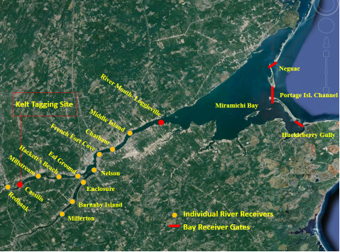
Portage Isl. Channel
Neguac
Huckleberry Gully
Figure 1. Location of acoustic receivers through Miramichi River and Miramichi Bay. Red circles indicate receivers used for tagging location (Cassilis), and survival out of river (Loggieville), yellow circles indicate individual receivers used to track in river movement. Red lines indicate multiple receivers used to determine survival out of Miramichi Bay (Neguac, Portage Island, Huckleberry Gully).

Table 1. Total number of kelt which received acoustic tags and percent survival through various locations and times between 2008 and 2013. * indicates that we can’t know this until next year, and only applies to kelt which received large, long term acoustic transmitters
Location | 2008 | 2009 | 2010 | 2011 | 2012 | Total 2013 | Angling only 2013
Kelts Tagged | 50 | 50 | 50 | 50 | 35 | 16 | 12
Head of tide (%) | 100 | 100 | 100 | 100 | 100 | 100 | 100
River mouth (%) | 96 | 92 | 90 | 94 | 94 | 75 | 100
Miramichi Bay (%) | 96 | 92 | 90 | 94 | 89 | 69 | 92
Strait of Belle Isle (%) | 44 | 18 | 14 | 30 | 14 | 38 | 50
Returned as consecutive (%) | 6 | 8 | 18 | 10 | 6 | 0 | 0
Returned as alternate (%) | 8 | 0 | 10 | 4 | 0 | * | *

Sea Survival and Movement

In 2013 a total of 11 tagged kelt successfully made it out of the Miramichi Bay. Three of these kelt were outfitted with long term V16 acoustic tags, while the remaining eight had pop-off satellite transmitters with short term V9 acoustic tags. Three of the eight satellite tags failed to transmit leaving five tags which transmitted temperature, depth and movement data.
Gulf of St. Lawrence: Three pop-off tags deployed prematurely within the Gulf of St Lawrence, but preliminary results from these fish have varied. Tag 128023 begin transmitting July 7, 2013 off the eastern tip of the Gaspe Peninsula (Fig 3.). Data from this tag show a marked increase in depth and temperature starting June 30, and continuing for 2 days. During this time no sunrise or sunset data was available, and the maximum recorded temperature reached 26.37 degrees Celsius. These results strongly indicate that this kelt was predated upon, and that the tag remained in the predators digestive system for 2 days before excretion. After the tag was expelled it floated to the surface on July 2, where it remained with unchanging pressure readings which triggered tag transmission.
Tag 128020 first transmitted northwest of the Magdalen Islands July 9, 2013 (Fig 3.). Temperature and depth data show a slow decline in temperature against a steady increase in depth, indicating that this fish died and began to slowly sink to the bottom, where it remained until its tag deployed. The cause of death cannot be determined, but could be attributed to numerous factors including an injury from a predator attack, inability to find sufficient food, or reduced fitness due to tagging equipment. Results from kelt 128019 (Fig 3.), which deployed north of PEI on June 17, are still being analyzed by Microwave Telemetry Incorporate and are not yet available for biological interpretation.

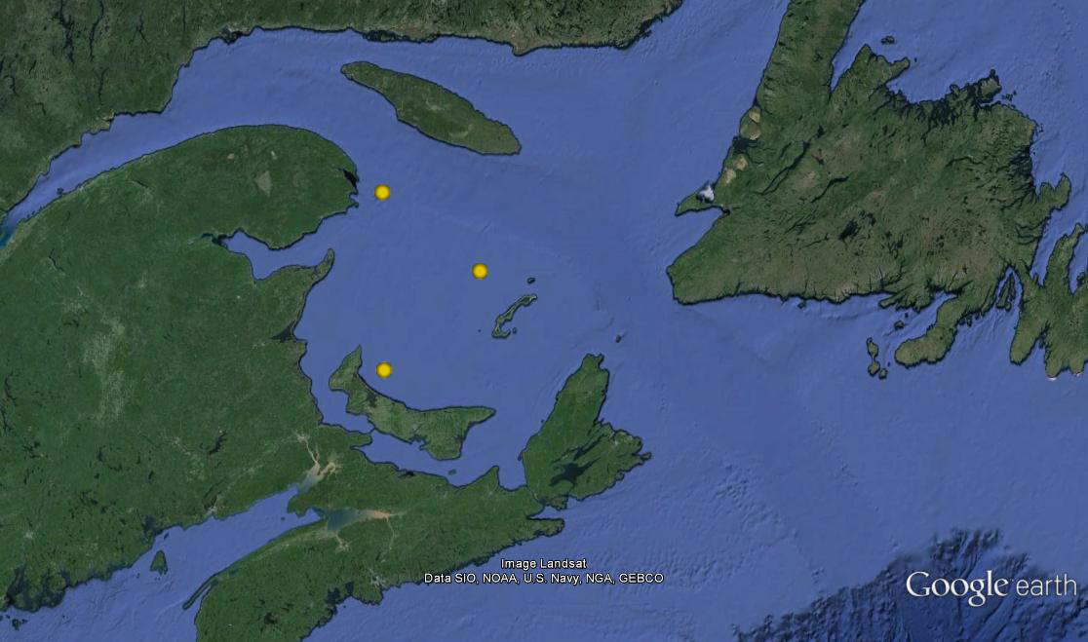
128023
128019
128020
Figure 2. Initial transmission locations for three satellite tagged kelt in the Gulf of St Lawrence

Strait of Belle Isle and Northern Waters: All three kelt outfitted with large acoustic tags travelled through the Strait of Belle Isle (SOBI), in migration to the waters of North Atlantic and Arctic Oceans. Two animals equipped with pop-off tags travelled through the Strait without being detected by acoustic receivers, but successfully deployed on schedule along the coasts of Labrador and Baffin Island. Movement trends from these fish are still being calculated. A third satellite tagged individual was acoustically detected at SOBI but failed to transmit. All fish picked up by sonic receivers were detected between July 6 and 7, 2013. Kelt tagged with Vemco V 16 tags arrived at SOBI receivers 57 to 60 days after last detection at Miramichi Bay, compared to 38 days for the lone detected satellite tag fish.

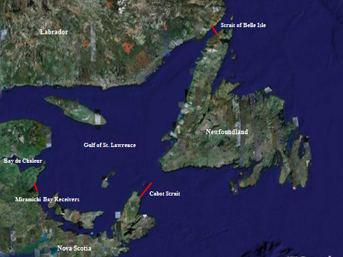
Figure 3. Locations of acoustic receiver lines deployed by ASF to track kelt movements

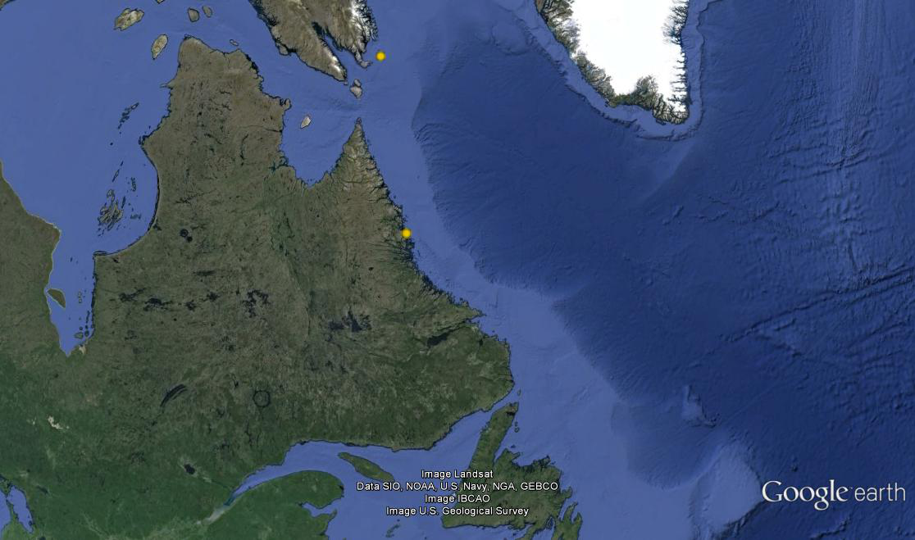
128017
128022
Figure 4. Initial transmission locations of satellite tagged kelt in North Atlantic and Arctic Oceans
Staging Areas

Fish with satellite tag numbers 128017, 128022, and 128023 exhibited potential staging behaviour during the month of June. From June 5 - 26, June 2 - 20, and June 6 - 19, respectively, these fish were located south of Anticosti Island and north of the Magdalen Islands in the Gulf of Saint Lawrence. The area occupied by the fish was approximately 40,000km² (Fig. 5). All three fish remained in average water temperatures of 8°C. The average depths occupied by each fish were 3.0m (128017), 3.2m (128022), and 6.5m (128023) during these weeks. This area appears to be a staging area for these fish, perhaps related to food sources (reconditioning), whether they later migrate further out into the Atlantic Ocean through the SOBI (alternate spawners) or remain in the Gulf (consecutive spawners).

Fish 128017 and 128022 moved out through the SOBI at the beginning of July. Fish 128023 remained in the Gulf and was believed to be consumed at the end of June. The two fish moving north remained in a large deep area (~410,000km²) near the Labrador Sea (Fig. 6) from mid-July until mid-August. During this time they began exhibiting very different behaviours than when they were in the Gulf. Both fish dove and ascended very quickly over the course of a day for multiple days; some dives were over 700m deep. The average depth for this period was 80m for both fish. The open water environment dropped the average temperature for this area to 6.5°C. This could be another staging area for alternate spawners, and the diving behaviour may be associated with food resources or predator avoidance. After the middle of August both fish moved further north towards Baffin Island and the deep diving behaviour stopped.
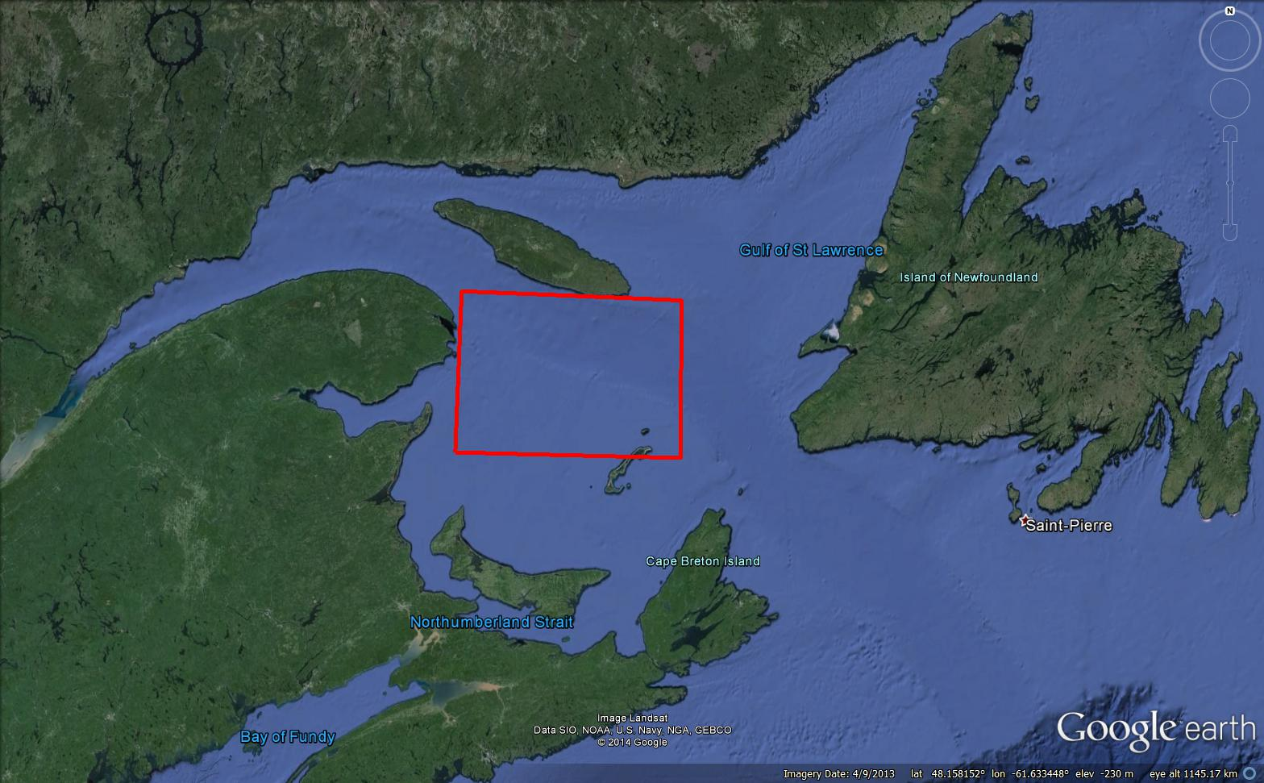

Figure 5. Potential staging area in the Gulf of Saint Lawrence. Three fish occupied this space during the month of June 2013.
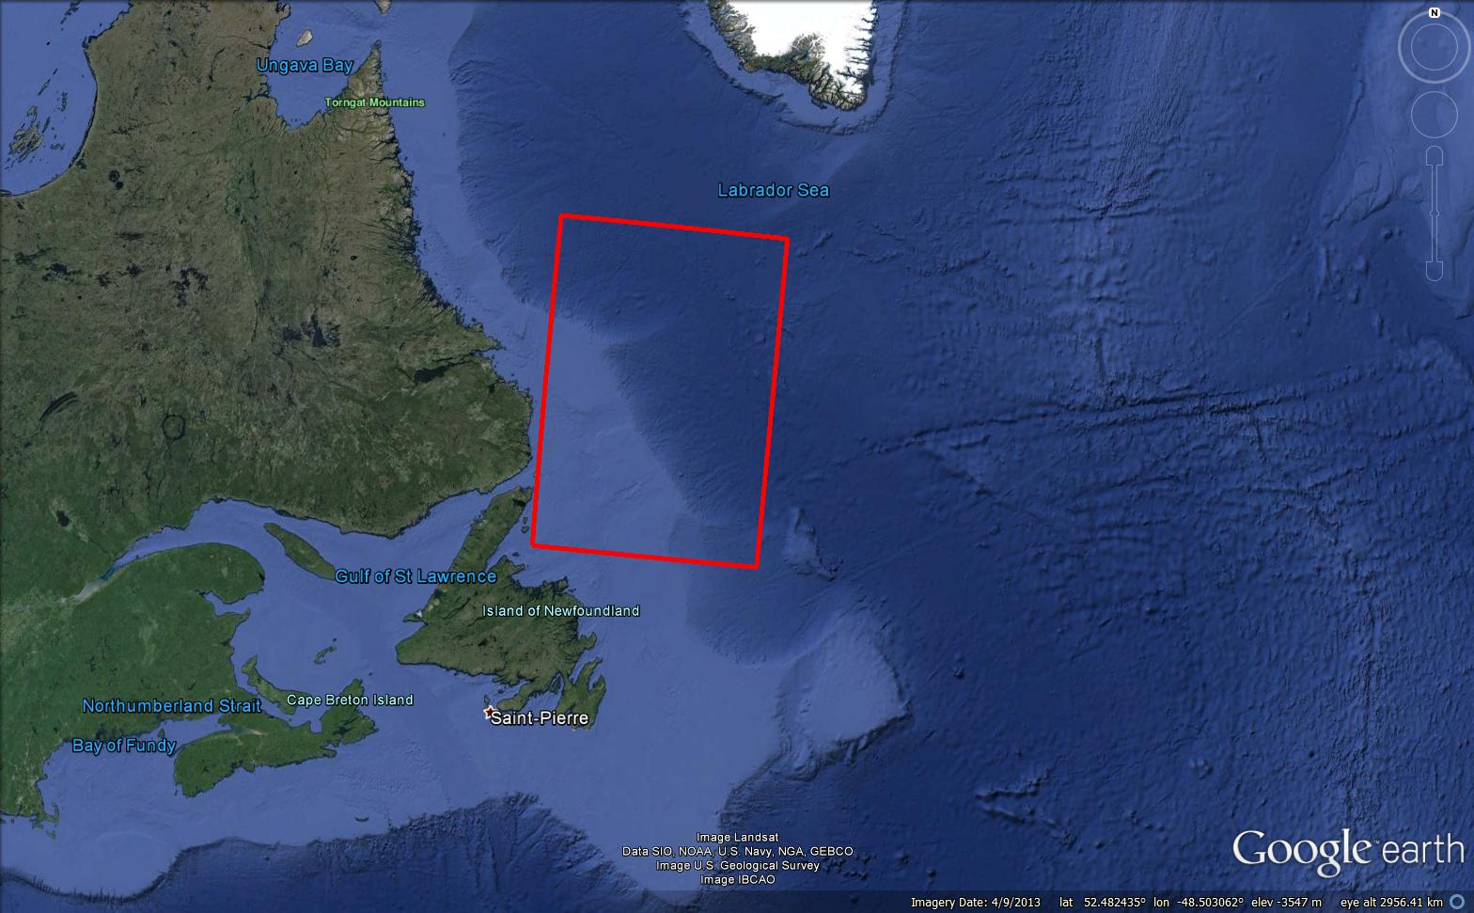
Figure 6. A second potential staging area in the North Atlantic for alternate spawners. Two fish were in this location from mid-July to mid-August 2013.

Tag Recovery

In 2013 a total of 4 satellite tags were able to be recovered after deployment. Two of these were attached to kelt which did not survive out of the river, a third was found on the south side of Miramichi Bay, and the final recovered tag was picked up off the north coast of PEI. All four tags will be refurbished for use during the 2014 study.

Discussion

In 2013 62.5% (5/8) of all satellite tagged kelt which survived through the Miramichi Bay successfully transmitted data on fish movements, temperature, and depths. Of the tags which failed to transmit, one was detected by acoustic receivers as it moved through the Strait of Belle Isle. The remaining two tags were not detected at the Strait or any other location, indicating that these fish failed to leave the Gulf of St Lawrence or were failed to be detected by acoustic receivers as they left. Failure of satellite tags to transmit could be the result of several factors which include technical failure, tag damage at sea, or lodging in the digestive track of a predator. Despite these failures, discussions with Microwave Telemetry Inc. (MTI) which produce these tags suggest that our return rate of data has been strong compared to other studies.
Two of the satellite pop-off tags deployed on schedule at preprogramed dates of August 31 (Baffin Island), and September 30 (Labrador), 2013. Initial satellite results suggest that these fish moved through the Strait of Belle Isle July 16 and July 3, respectively. Although these dates may be subject to change following further analysis, both fall in early July, during the same time that all acoustically tagged fish (July 6 and 7) were detected. Given the northern location and late season timing of transmission of both tags, it is safe to speculate that these kelts were alternate spawners on their way to recondition in cold northern waters before returning to spawn in 2014. Advanced analysis of the data from these two tags is ongoing, and will be used with past and future data to investigate trends in kelt movements to determine statistically relevant behavioral patterns which may provide significant insight into the ecology of alternate spawning salmon.
Of the two prematurely deployed tags in the Gulf of St Lawrence which data is currently available for, only one at this time can be considered for probable predation. Data on tag 128020, which appears to have sunk to the sea floor, will be compared to other kelt throughout the ongoing study to determine if depth and temperature data before the cessation of movement may have indicated a weaker condition of the fish compared to other tagged animals. Temperature and light analysis from tag 128023 suggest a high probability of predation. Further analysis of temperature and depth occupied this time may provide insight as to what species of animal consumed this kelt. Pop-off dates of both these fish occurred within 2 days of each other, July 7 and 9, 2013 which, after excluding the 5 days of inactivity before transmission, means that these tags were floating at the surface July 2 and 4. Although too small to draw any conclusions from, pooling the data from these fish with kelts from past and future studies which also prematurely deploy in the Gulf may provide correlations between survival and water temperature, seasonal commercial fisheries, or predator movements. Initial biological analysis of kelt 128019 is currently awaiting data summation by MTI.
Determining movement tracks of individual fish requires considerable work and statistical analysis. As previously mentioned, tag position is determined by converting daily recorded light intensity and duration to sunrise and sunset timing. Positioning is then determined by calculating the marine area would have those same times for a specific date. Although this method is effective, it is also prone to false locations produced by environmental conditions. Significant cloud cover during dawn or dusk where light levels are low can give the impression of delayed sunset or early sunrise, thus changing the position calculated for the location. An initial correction factor can be applied by averaging positions at a specific date with values collected during the previous days. This method provides a simplified improvement to smooth out data, but is still impacted by outlying erroneous locations. In order to correct for this, all positions need to be compared against local weather conditions during the specific date the animal was thought to be in a given area. At this time simplified tracks of three kelt have been completed, which are included in Appendix 1 of this report. The locations and times of these tracks are not yet considered final, and are likely to change during further refinement.
In 2013, survival of acoustic only and satellite tagged fish through the river and bay was significantly lower than past years of this study. This is likely the combination of several factors including early spring conditions, warmer water, stress from the trap net, or possibly poorer fitness of later run kelt. These factors contributed to complete mortality of late tagged fish, which artificially lowered Miramichi River (75%) and Miramichi Bay (69%) survival rates. The exclusion of these fish changes survival rates to 100% and 92%, respectively, which are more in line with averages of 93% and 92% for river and bay survival for studies from previous years. Based on these findings all future sampling events will be planned for earlier in the spring to avoid detrimental impacts to scientific studies and unnecessary harm to the animals. Furthermore, trap netting will be avoided as a fishing option in future studies.

Appendix 1. Mapping of Kelt Tracks

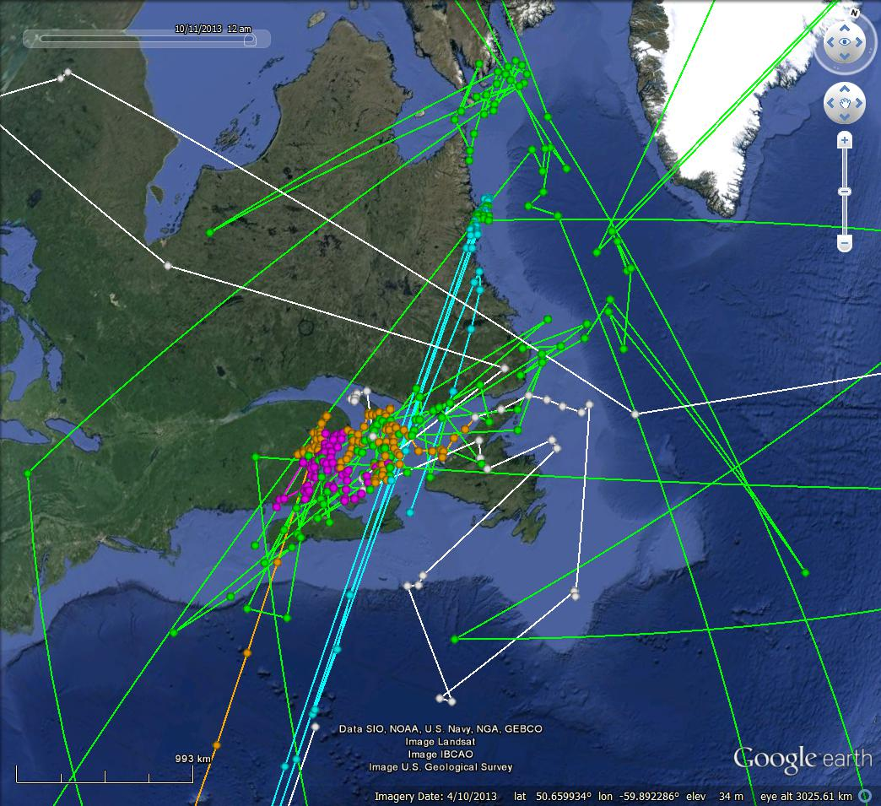
Figure 7. Unrefined tracks of five satellite tagged kelt from the Northwest Miramichi. Colors indicated individual fish movements.

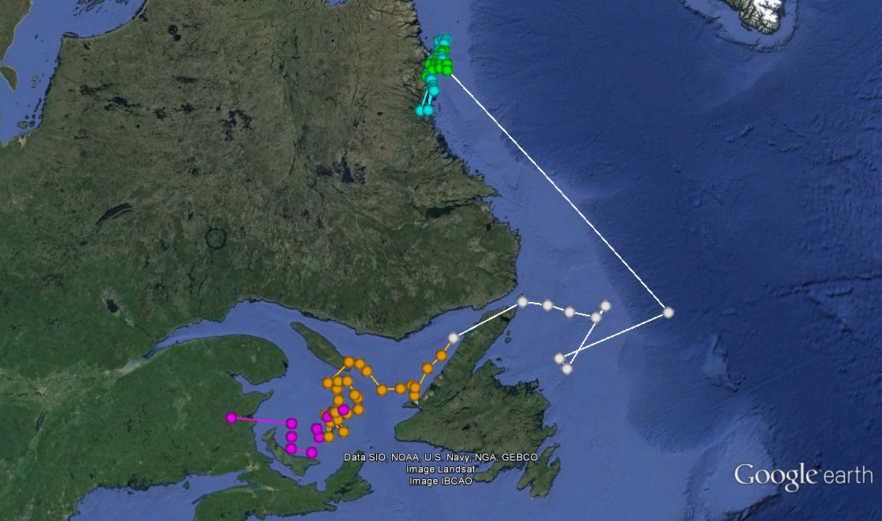
Figure 8. Smoothed track of kelt 128022 which deployed off the coast of Labrador September 30, 2013. Colors indicate month (Pink: May, Orange: June, White: July, Green: August, Blue: September)
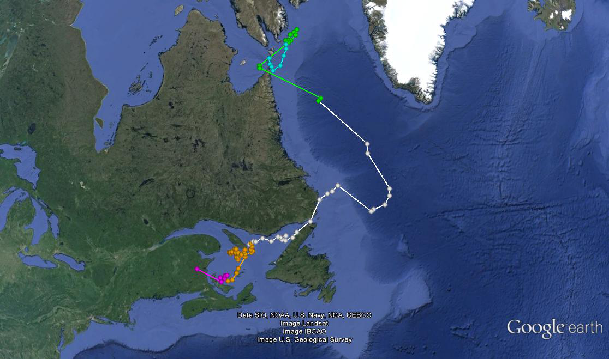
Figure 9. Smoothed track of kelt 128017 which deployed off the southern tip of Baffin Island August 31, 2013. Colors indicate month (Pink: May, Orange: June, White: July, Green: August, Blue: September). All blue Septembers tracks are an artifact of the tag transmission while floating at sea

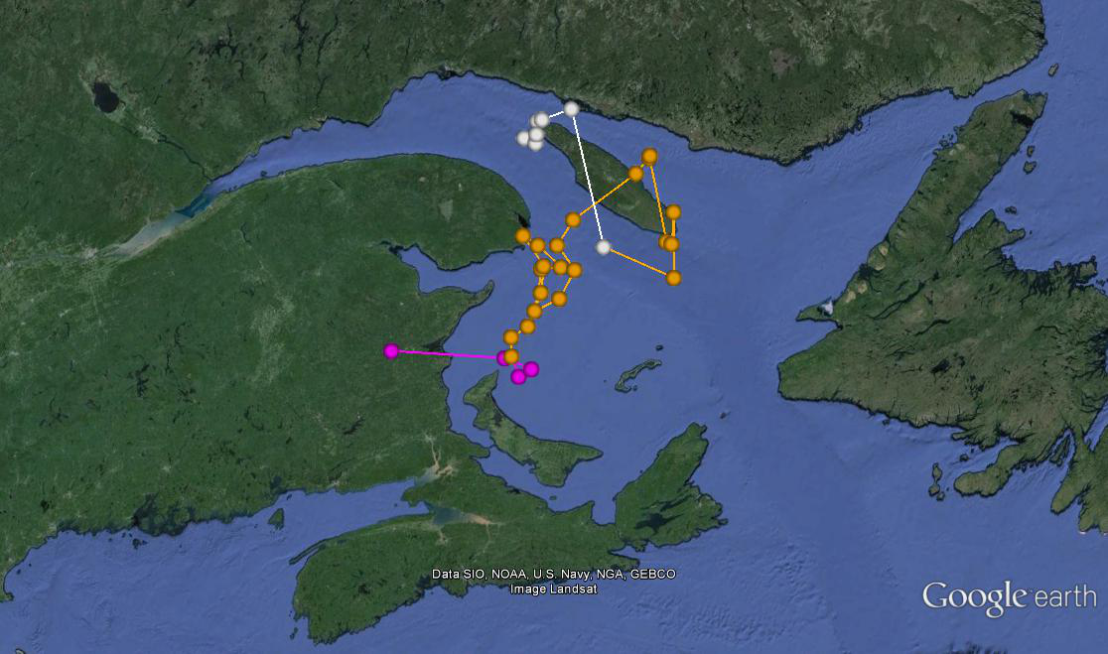
Figure 10. Smoothed track of kelt 128023 which deployed off the coast of Gaspe September 30, 2013. Colors indicate month (Pink: May, Orange: June, White: July)

